2012 FIM-North America Continental Rally
42nd Bluenose Rally

28 June – 1 July 16, 2012

Billtown, Nova Scotia

This year’s FIM-NA Continental Rally was the annual Bluenose Rally organized by the Apple Valley Riders Motorcycle Club, a Canadian Motorcycle Association affiliate based in the Annapolis Valley agricultural region of the Canadian province of Nova Scotia.

This was the club’s 42nd annual running of their Bluenose Rally.

The weather was impeccable for riding & camping; sunny & warm, unlike much of eastern North America which was dull, soggy & wet.

The Rally was based at the club’s campground in the hamlet of Billtown, near Kentville, the major town & the administrative centre for the area. Prominent on the registration building was a new “FIM North America Rally” banner with FIM-NA, CMA & AMA logos.

ORGANIZING CLUB
Despite being small in numbers, the Apple Valley Riders have established an excellent reputation for hosting well run, enjoyable rallies. This year’s effort enhanced that reputation. They get some assistance from other area motorcycle groups. They also seem to get excellent co-operation & tolerance from local authorities & residents, especially with respect to traffic control, managed by club members for the Sunday morning mass ride/parade.

President – Lyle Fowler; Vice-President – Reid Sanford
Treasurer – Brian Porter; Secretary – Bonnie Sanford

6 Beckwith Street, Wolfville, Nova Scotia, Canada. B4P 1R4
www.bluenoserally.com

LOCATION
The club’s facilities are at Billtown in Nova Scotia’s Annapolis Valley region, the major agricultural area in the province. The area is renowned for its apples, small wineries and wide range of farm products. It is about 1¼ hours northwest of Halifax, the provincial capital. The first Europeans to settle the area were the French in the 1600s. The valley is well established with numerous interesting small towns and locations to visit, from pastoral farm markets to cliff side fishing hamlets on the Bay of Fundy shore. The valley benefits from a more pleasant climate than the rest of Nova Scotia; a range of moderate hills to the north protects it from the harsher Fundy weather.

SITE
The Rally base, the club’s campground, is well set up with a choice of pleasant camping areas, in either the central field or in the surrounding wooded area. One of the two buildings on site contains a kitchen, an indoor dining room, a covered outdoor dining area, washrooms and showers. The other serves for administration & registration.

ACCOMODATION
In addition to camping at the Rally site there are hotels, motels, cottages and B&Bs in the vicinity.

PARTICIPANTS
The number of registered rallyists was 241, noticeably more than last year. Most participants were older, mature types with extensive motorcycle touring experience. Most machines were larger, touring types, some towing trailers, and a number of modern 3-wheelers. There were noticeably more Can-Am Spyder 3-wheelers than in past years. It remains to be seen whether Can-Am’s extensive marketing of their innovative 3-wheel concept is converting existing touring motorcyclists or, bringing new people into motorcycling & motorcycle touring.

Although this might be considered a small rally it is well regarded by those who attend. A large number return year after year, some for 20, 30 & 40 years. Most attendees are from eastern & central regions of Canada & the U.S. This year there were attendees from as far away as southern Ontario & Missouri.

ACTIVITIES
Fun runs, short tours, field events, Saturday night dance with live band, Sunday church service, parade, induction of newcomers into Nova Scotia’s Order of Good Cheer (the Order dates from the early 1600s). Other area motorcycle groups assisted the host club: the BMW Owners of Nova Scotia for the Friday evening Welcome Festivities; members of the Christian Motorcyclists Association organized the Saturday afternoon field event competitions; the Antigonish Touring Society for Saturday breakfast.

FOOD
The food highlight was the Saturday night Hog Roast (4-legged, not 2-wheeled). Another food highlight was the Sunday awards brunch in the dining room of Acadia University. Brunch followed a mass ride/parade to the university’s campus in the next town of Wolfville, some 20 km. away. The location is impressive as the university’s dining room is on the side of a hill, with large windows overlooking the valley and the Bay of Fundy in the distance.

DOOR PRIZES
The club held a draw for “door” prizes obtained by the club. I added a small number of FIM promotional items (key rings, FIM-NA pins, pens, magazine, etc.).

MAJOR AWARDS
Trophies
Oldest Rallyist – Ray Simms (79 years 10 months and 16 days)
Oldest Machine – Honda Goldwing 1000 1979, Tim Arsenault (PE)

High Mileage Machine – 400, 385: Rod Hughes
Best Represented Club - 22 members: Southwest Nova Bikers Assoc.
Road Rider (auction) - Dale Eineder, Zanesville, OH
Average Mileage – Clive Lahey, Main-A-Dieu, NS
High Mileage International – Gene Dudley, Dixon, MO
High Mileage National – Ron Johnston, Milton, ON

Special Presentation by John Pineo to Apple Valley Riders: The CMA Supporters Awards

Graham Read - Delegate – FIM/NA
20 July 2011
REGISTRATION

GUEST OF HONOUR

SATURDAY HOG ROAST
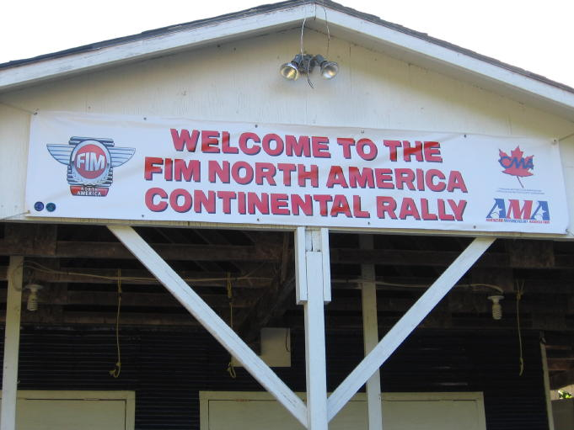
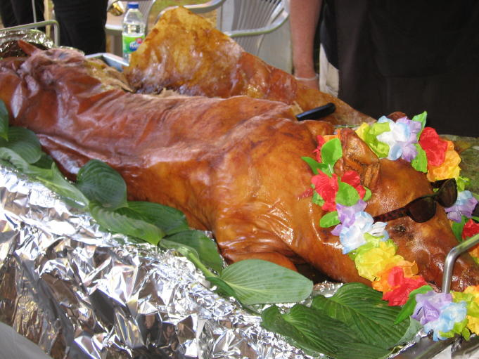

SOME OF THE “INTERESTING” MACHINE CHOICES
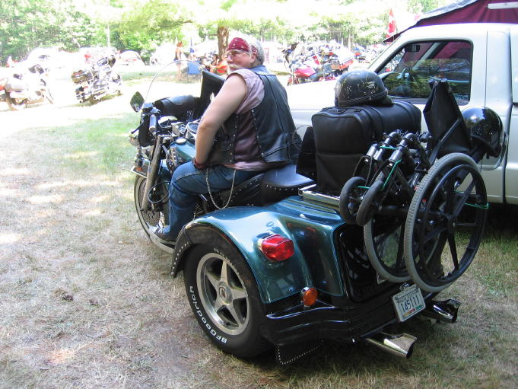
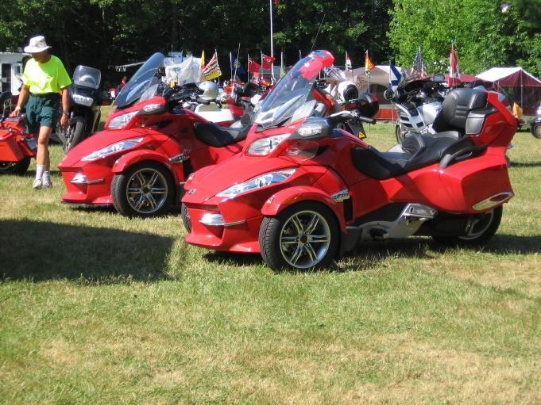

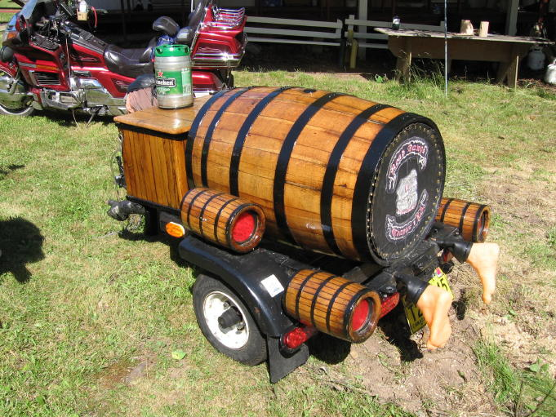

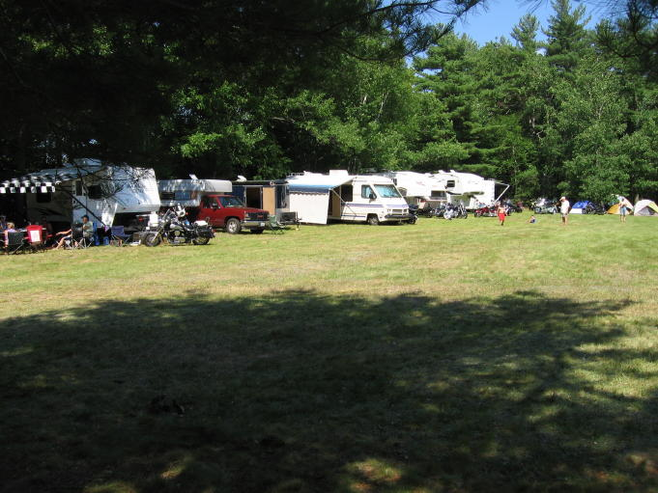
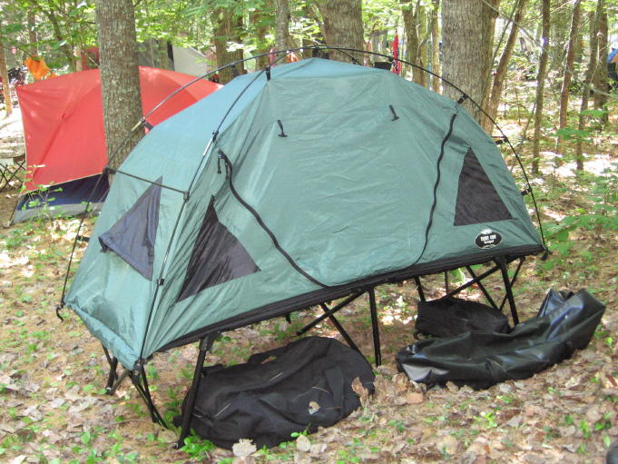SOME CAMPING CHOICES

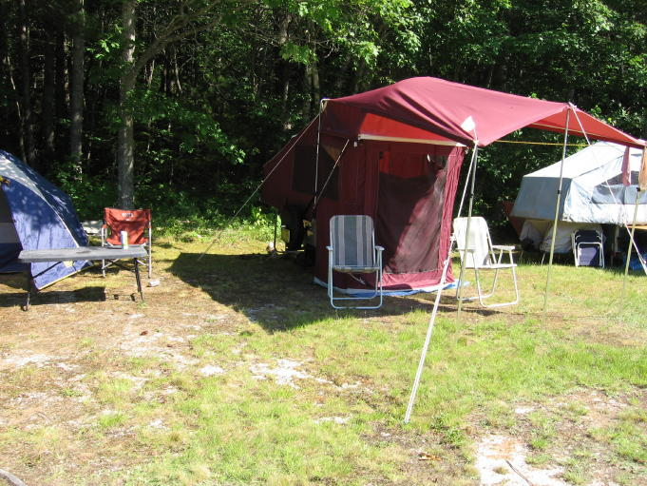
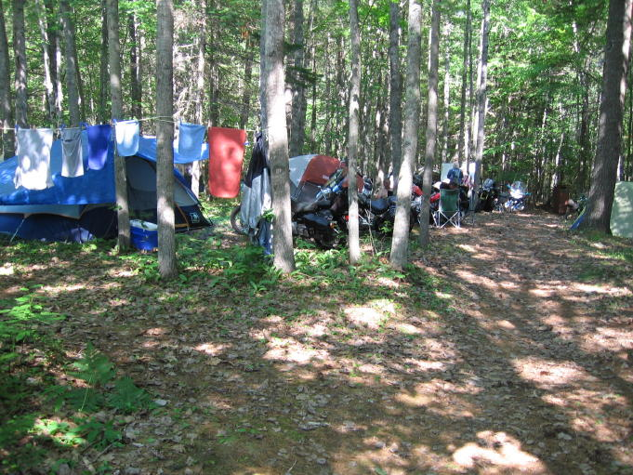
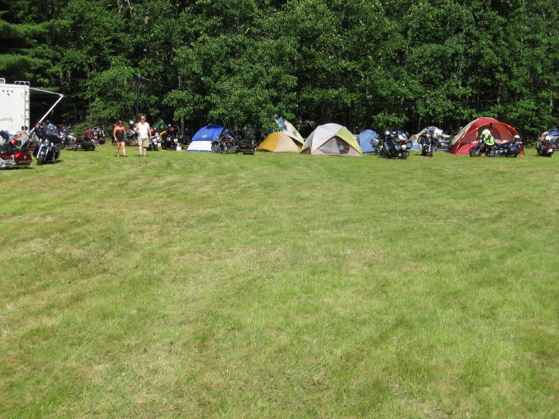
SUNDAY MORNING PARADE
(getting ready)

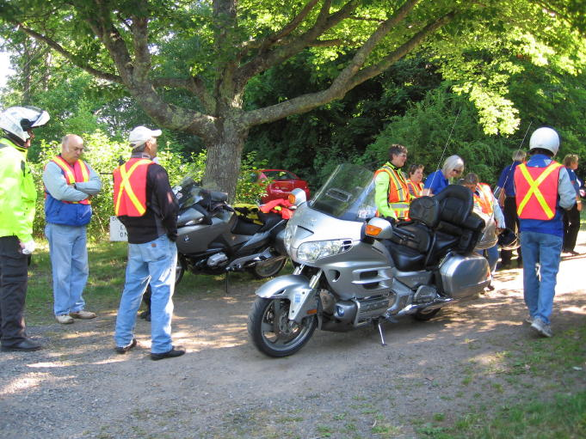
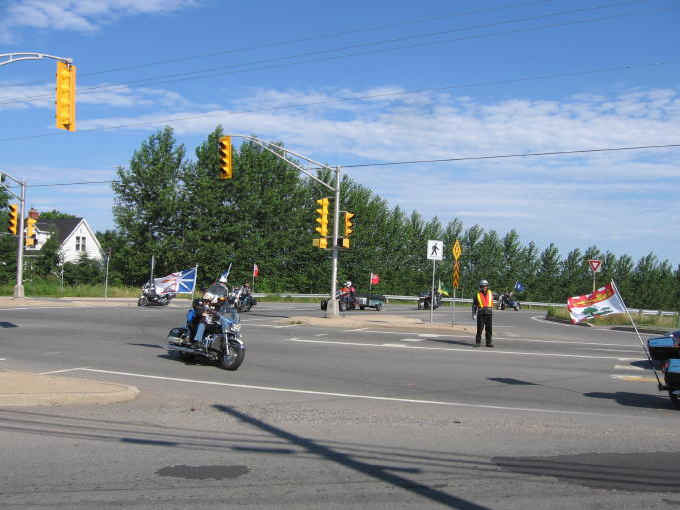

SUNDAY BRUNCH AT ACADIA UNIVERSITY
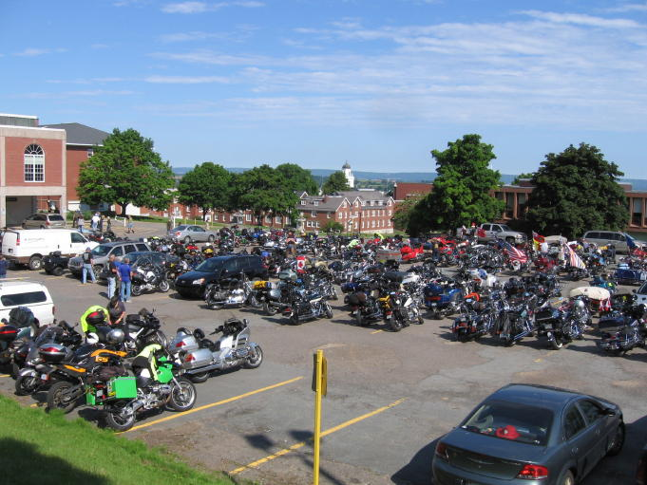
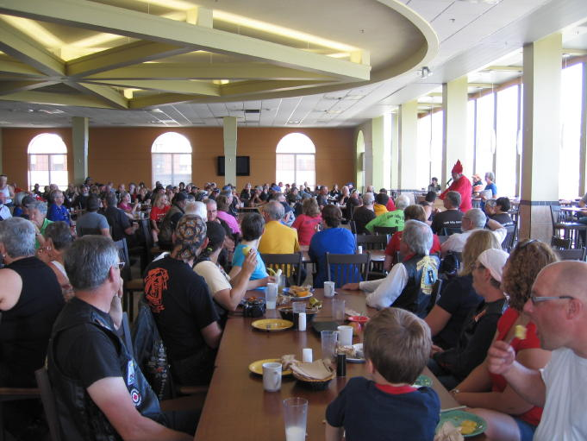

(on the way to brunch)

PARKING AT ACADIA
(overlooking Bay of Fundy)

